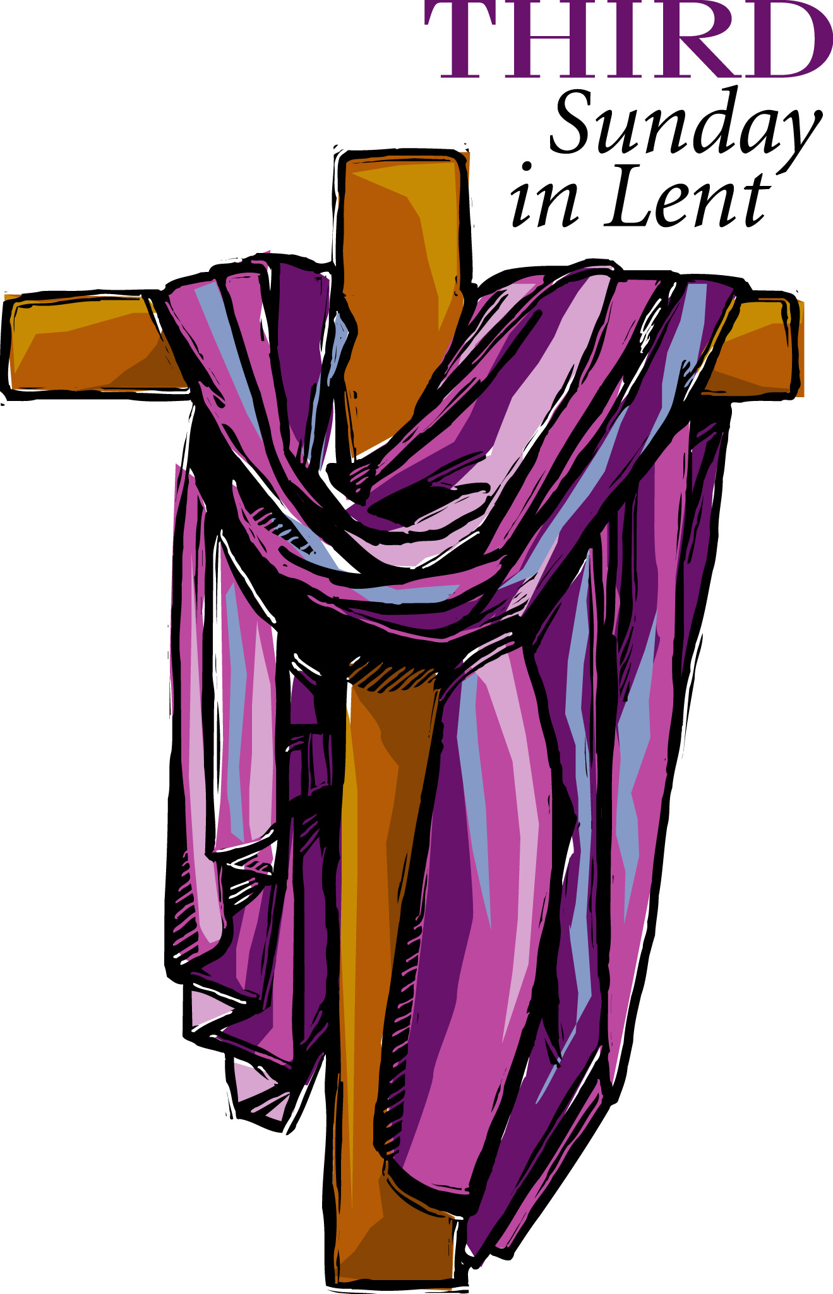
Welcome To
Trinity Lutheran Church
Lutheran Church—Missouri Synod
A Stephen Ministry Congregation

1354 South Otsego Avenue
Gaylord, Michigan 49735
Church Phone: (989) 732-4816

Church Email: secretary@trinitygaylord.com
www.trinitygaylord.com

Office Hours: Monday through Friday 9am – 1pm

OUR PURPOSE

…is to LOVE GOD, LOVE OTHERS, AND SERVE THE WORLD by worshiping the Lord Jesus, bringing our members into Christ-like maturity, and equipping them through Word and Sacrament for their mission and ministry. We go heart to heart into the world with Jesus, sharing His love, caring for one another, praying, and bringing the lost into a relationship with Christ, by the working of the Holy Spirit.

March 12, 2023
Third Sunday in Lent
Preacher: Rev. Ken Bernthal

ABOUT OUR WORSHIP
We welcome all who gather here today! We are blessed to celebrate together the mercy, grace, and love we have from God through the death and resurrection of our Lord Jesus Christ.

Children: Families with children are very welcome here. Having children in church is important so they can begin to learn about their faith in Jesus, and it’s good for the whole congregation to see. Please feel comfortable keeping “squirmy” kids in the service. This is where they belong, too!

Pew Cards: Guests and Members, please fill out the Guest/Member card located on the back of the pew in front of you and pass it to the end of the aisle. If you forget you can put it in the offering plate on your way out.

If standing is difficult: Please feel free to remain seated during any portion of the service. Please let an Elder or Usher know if you need communion in your pew seat.

About our celebration of Holy Communion: We celebrate the Lord’s Supper in the confession and glad confidence that, as he says, our Lord gives into our mouths not only bread and wine but his very body and blood to eat and to drink for the forgiveness of sins and to strengthen our union with him and with one another. Our Lord invites to his table those who trust his words, repent of all sin, and set aside any refusal to forgive and love as he forgives and loves us, that they may show forth his death until he comes.

Because those who eat and drink our Lord’s body and blood contrary to that which is stated above do so to their great harm, and also because Holy Communion is a confession of the faith which is confessed at this altar. Anyone who is not yet instructed, in doubt, or who hold a confession differing from that of the Lutheran Church—Missouri Synod, and yet desire to receive the sacrament, are asked first to speak with Pastor. Those not communing are still invited to come forward for a blessing from Pastor, and you may indicate this by crossing your arms over your chest.
TTTTTT
GREETING

P Peace be with you.
C And also with you.

T ORDER OF SERVICE T
(The liturgy is from Divine Service Setting four LSB pg. 203ff)

OPENING HYMN
Christ, the Life of All the Living LSB 420 sts. 1–4
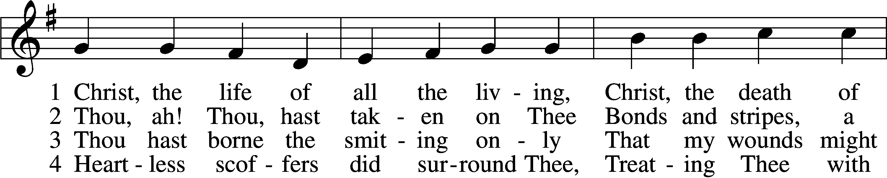
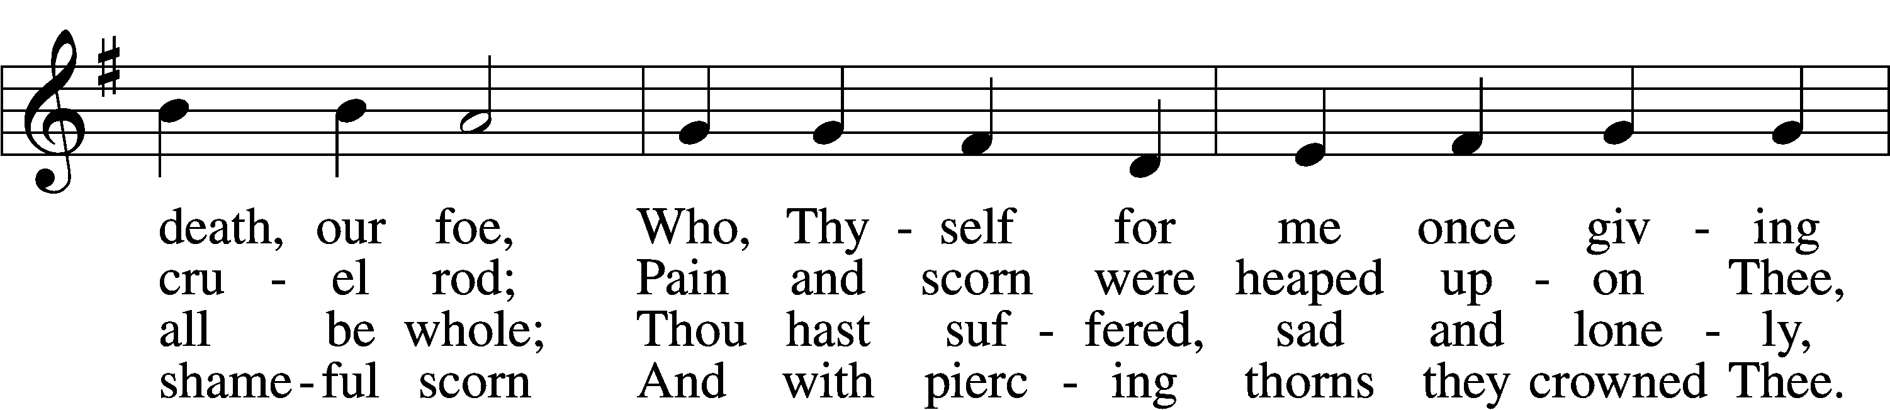
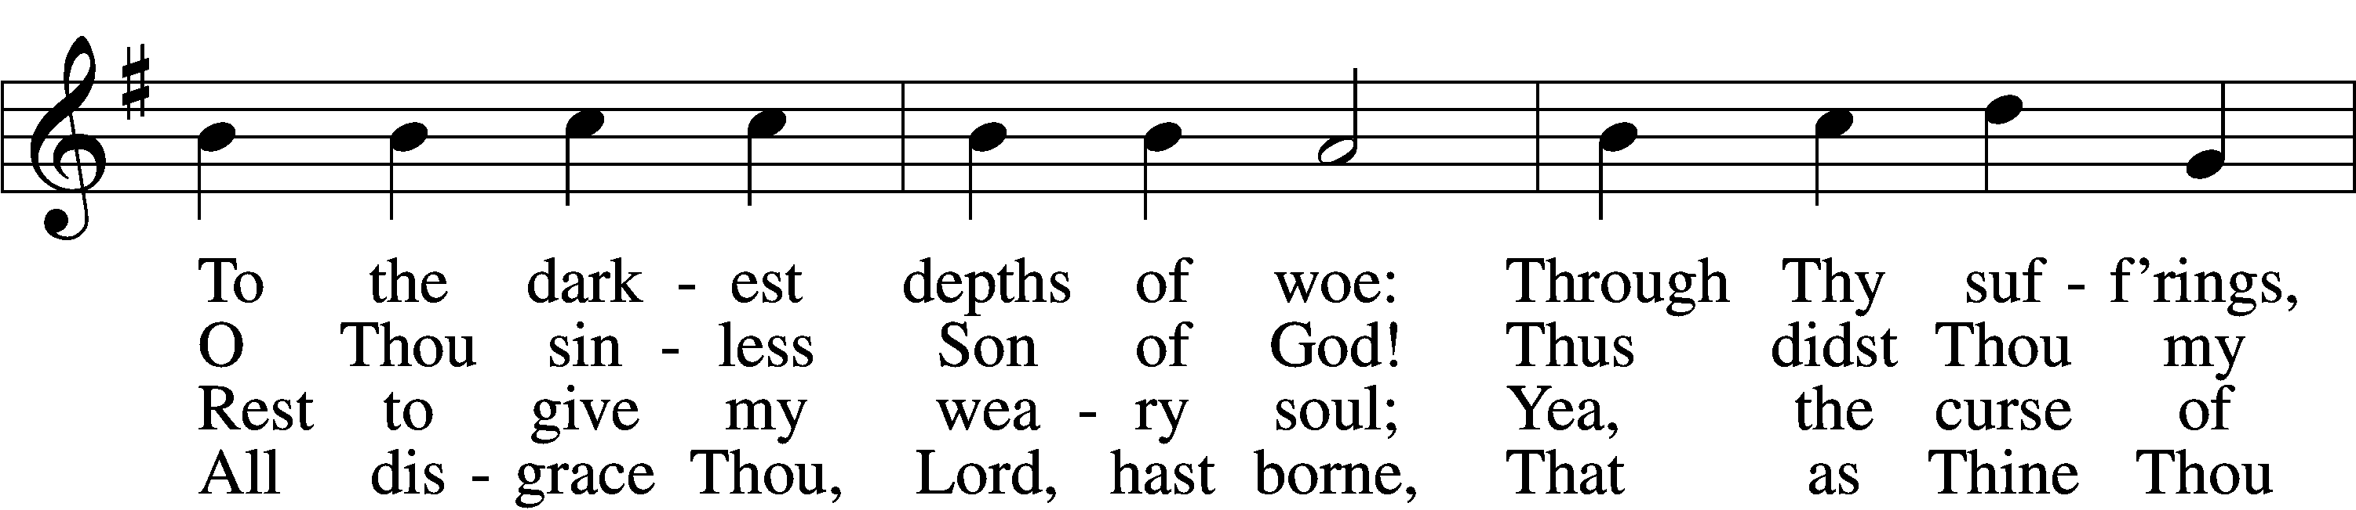
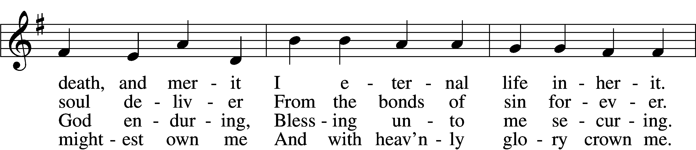
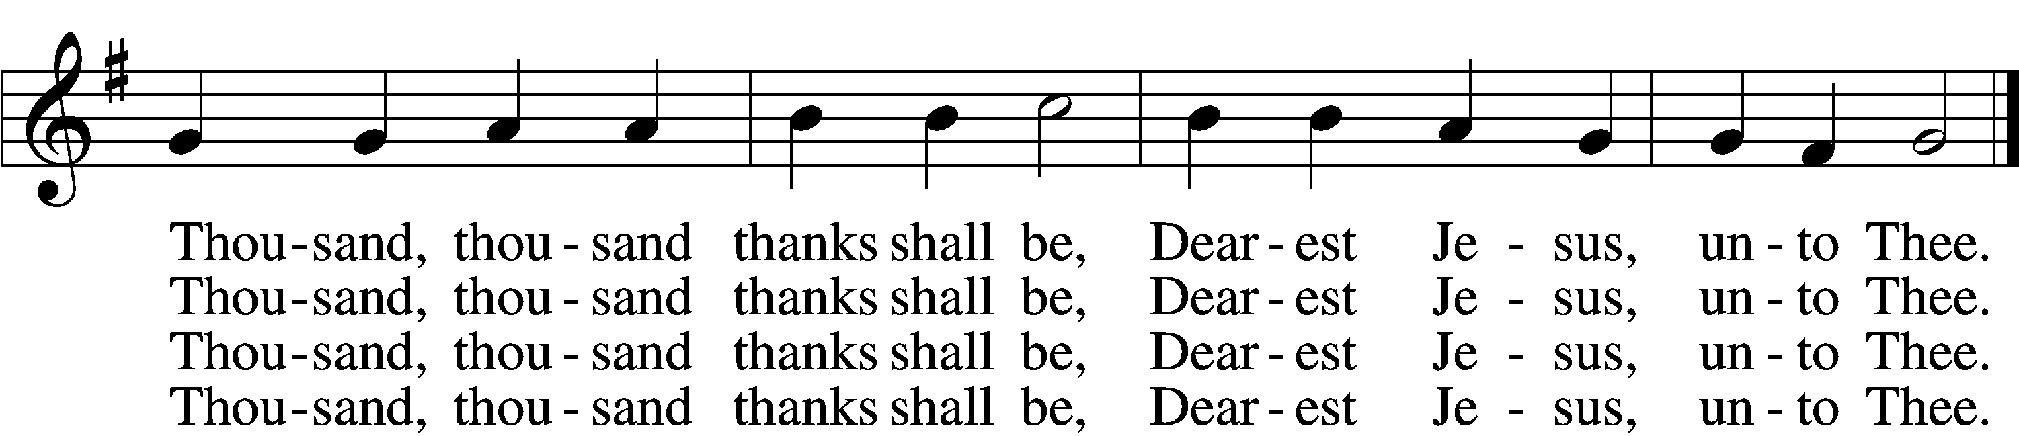
Please stand as able

CONFESSION and ABSOLUTION
The sign of the cross may be made by all in remembrance of their Baptism.
P In the name of the Father and of the T Son and of the Holy Spirit.
C Amen.
P Our help is in the name of the Lord,
C who made heaven and earth.
P If You, O Lord, kept a record of sins, O Lord, who could stand?
C But with You there is forgiveness; therefore You are feared.
P Since we are gathered to hear God’s Word, call upon Him in prayer and praise, and receive the body and blood of our Lord Jesus Christ in the fellowship of this altar, let us first consider our unworthiness and confess before God and one another that we have sinned in thought, word, and deed, and that we cannot free ourselves from our sinful condition. Together as His people let us take refuge in the infinite mercy of God, our heavenly Father, seeking His grace for the sake of Christ, and saying: God, be merciful to me, a sinner.
C Almighty God, have mercy upon us, forgive us our sins, and lead us to everlasting life. Amen.
P Almighty God in His mercy has given His Son to die for you and for His sake forgives you all your sins. As a called and ordained servant of Christ, and by His authority, I therefore forgive you all your sins in the name of the Father and of the T Son and of the Holy Spirit.
C Amen.
T SERVICE OF THE WORD T
INTROIT Psalm 25:1–2, 17–18, 20; antiphon: vv. 15–16
P My eyes are ever toward the Lord,
for he will pluck my feet out of the net.
C Turn to me and be gracious to me,
for I am lonely and afflicted.
P To you, O Lord,
I lift up my soul.
C O my God, in you I trust; let me not be put to shame;
let not my enemies exult over me.
P The troubles of my heart are enlarged;
bring me out of my distresses.
C Consider my affliction and my trouble,
and forgive all my sins.
P Oh, guard my soul, and deliver me!
Let me not be put to shame, for I take refuge in you.
A Glory be to the Father and to the Son
and to the Holy Spirit;
as it was in the beginning,
is now, and will be forever. Amen.
C My eyes are ever toward the Lord,
for he will pluck my feet out of the net.
P Turn to me and be gracious to me,
for I am lonely and afflicted.

KYRIE LSB 204
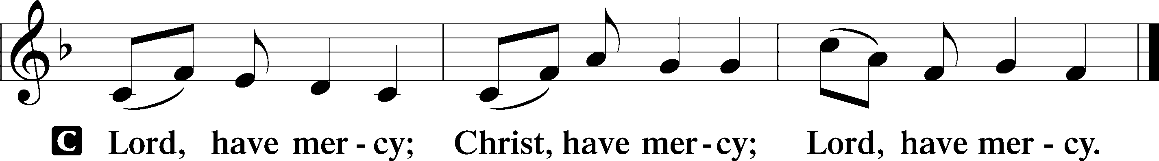

SALUTATION AND COLLECT OF THE DAY
P The Lord be with you.
C And also with you.
P Let us pray.
O God, whose glory it is always to have mercy, be gracious to all who have gone astray from Your ways and bring them again with penitent hearts and steadfast faith to embrace and hold fast the unchangeable truth of Your Word; through Jesus Christ, Your Son, our Lord, who lives and reigns with You and the Holy Spirit, one God, now and forever.
C Amen.
Please be seated
OLD TESTAMENT READING Exodus 17:1–7
¹All the congregation of the people of Israel moved on from the wilderness of Sin by stages, according to the commandment of the Lord, and camped at Rephidim, but there was no water for the people to drink. ²Therefore the people quarreled with Moses and said, “Give us water to drink.” And Moses said to them, “Why do you quarrel with me? Why do you test the Lord?” ³But the people thirsted there for water, and the people grumbled against Moses and said, “Why did you bring us up out of Egypt, to kill us and our children and our livestock with thirst?” ⁴So Moses cried to the Lord, “What shall I do with this people? They are almost ready to stone me.” ⁵And the Lord said to Moses, “Pass on before the people, taking with you some of the elders of Israel, and take in your hand the staff with which you struck the Nile, and go. ⁶Behold, I will stand before you there on the rock at Horeb, and you shall strike the rock, and water shall come out of it, and the people will drink.” And Moses did so, in the sight of the elders of Israel. ⁷And he called the name of the place Massah and Meribah, because of the quarreling of the people of Israel, and because they tested the Lord by saying, “Is the Lord among us or not?”

P This is the Word of the Lord.
C Thanks be to God.

EPISTLE READING Romans 5:1–8

¹Therefore, since we have been justified by faith, we have peace with God through our Lord Jesus Christ. ²Through him we have also obtained access by faith into this grace in which we stand, and we rejoice in hope of the glory of God. ³More than that, we rejoice in our sufferings, knowing that suffering produces endurance, ⁴and endurance produces character, and character produces hope, ⁵and hope does not put us to shame, because God’s love has been poured into our hearts through the Holy Spirit who has been given to us.
⁶For while we were still weak, at the right time Christ died for the ungodly. ⁷For one will scarcely die for a righteous person—though perhaps for a good person one would dare even to die— ⁸but God shows his love for us in that while we were still sinners, Christ died for us.

P This is the Word of the Lord.
C Thanks be to God.

Please stand as able

VERSE
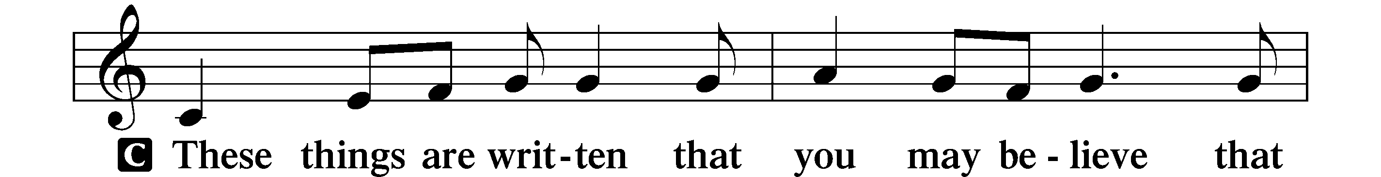
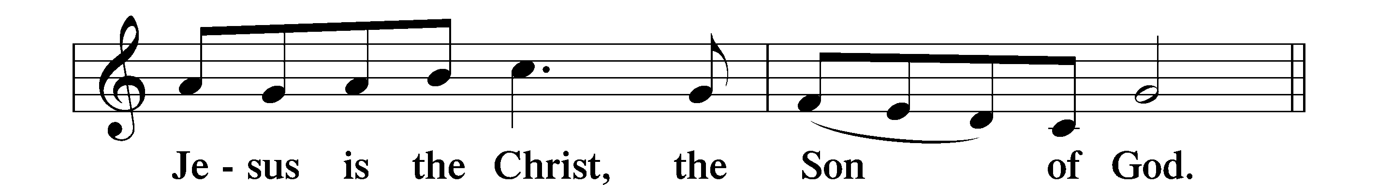

HOLY GOSPEL John 18:28–38
P The Holy Gospel according to St. John, the eighteenth chapter.
C Glory to You, O Lord.

²⁸Then they led Jesus from the house of Caiaphas to the governor’s headquarters. It was early morning. They themselves did not enter the governor’s headquarters, so that they would not be defiled, but could eat the Passover. ²⁹So Pilate went outside to them and said, “What accusation do you bring against this man?” ³⁰They answered him, “If this man were not doing evil, we would not have delivered him over to you.” ³¹Pilate said to them, “Take him yourselves and judge him by your own law.” The Jews said to him, “It is not lawful for us to put anyone to death.” ³²This was to fulfill the word that Jesus had spoken to show by what kind of death he was going to die.
³³So Pilate entered his headquarters again and called Jesus and said to him, “Are you the King of the Jews?” ³⁴Jesus answered, “Do you say this of your own accord, or did others say it to you about me?” ³⁵Pilate answered, “Am I a Jew? Your own nation and the chief priests have delivered you over to me. What have you done?” ³⁶Jesus answered, “My kingdom is not of this world. If my kingdom were of this world, my servants would have been fighting, that I might not be delivered over to the Jews. But my kingdom is not from the world.” ³⁷Then Pilate said to him, “So you are a king?” Jesus answered, “You say that I am a king. For this purpose I was born and for this purpose I have come into the world—to bear witness to the truth. Everyone who is of the truth listens to my voice.” ³⁸Pilate said to him, “What is truth?”
After he had said this, he went back outside to the Jews and told them, “I find no guilt in him.

P This is the Gospel of the Lord.
C Praise to You, O Christ.

NICENE CREED
I believe in one God,
the Father Almighty,
maker of heaven and earth
and of all things visible and invisible.

And in one Lord Jesus Christ,
the only-begotten Son of God,
begotten of His Father before all worlds,
God of God, Light of Light,
very God of very God,
begotten, not made,
being of one substance with the Father,
by whom all things were made;
who for us men and for our salvation came down from heaven
and was incarnate by the Holy Spirit of the virgin Maryand was made man;
and was crucified also for us under Pontius Pilate.
He suffered and was buried.
And the third day He rose again according to the Scriptures
and ascended into heaven
and sits at the right hand of the Father.
And He will come again with glory to judge both the living
and the dead,
whose kingdom will have no end.
And I believe in the Holy Spirit,
the Lord and giver of life,
who proceeds from the Father and the Son,
who with the Father and the Son together is worshiped and
glorified,
who spoke by the prophets.
And I believe in one holy Christian and apostolic Church,
I acknowledge one Baptism for the remission of sins,
and I look for the resurrection of the dead
and the life T of the world to come. Amen.

Please be seated

ALL GOD’S CHILDREN – TALK

SERMON HYMN
O Savior, Precious Savior LSB 527
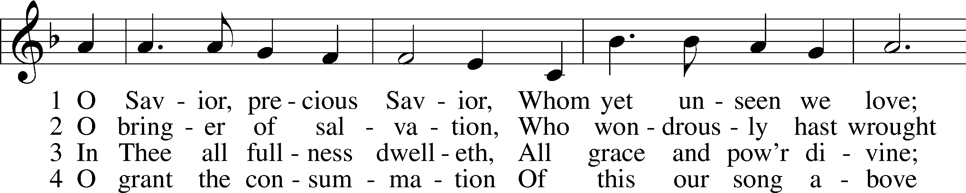
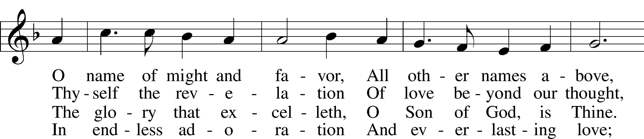
Continued on next page
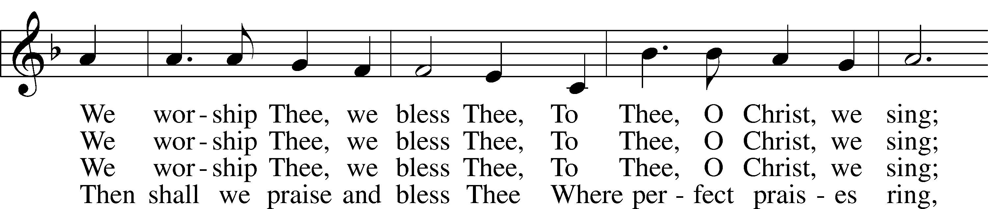
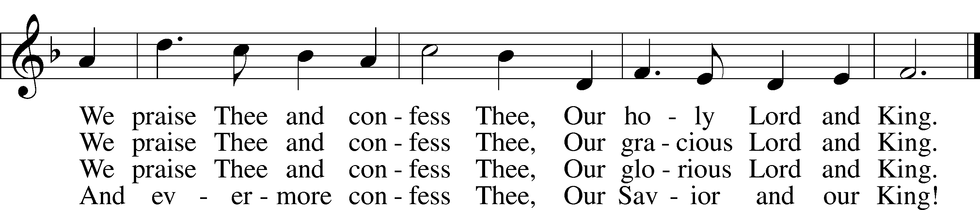

SERMON “PONTIUS PILASTE, WERE YOU THERE?”
Please stand as able

PRAYER of the CHURCH
After each Segment:
P Lord, in Your Mercy,
C Hear our Prayer.
Final Segment:
P Hear us as we pray in His name and as He has taught us:

LORD’S PRAYER
Our Father who art in heaven,
Hallowed be thy name,
Thy kingdom come,
Thy will be done
On earth as it is in heaven.
Give us this day our daily bread;
And forgive us our trespasses
As we forgive those
Who trespass against us;
And lead us not into temptation,
But deliver us from evil.
For thine is the kingdom
And the power and the glory
Forever and ever. Amen
T SERVICE OF THE SACRAMENT T

PREFACE LSB 208
P The Lord be with you.
C And also with you.
P Lift up your hearts.
C We lift them to the Lord.
P Let us give thanks to the Lord our God.
C It is right to give Him thanks and praise.

P It is truly good, right, and salutary that we should at all times and in all places give thanks to You, O Lord, holy Father, almighty and everlasting God, for the countless blessings You so freely bestow on us and all creation. Above all, we give thanks for Your boundless love shown to us when You sent Your only-begotten Son, Jesus Christ, into our flesh and laid on Him our sin, giving Him into death that we might not die eternally. Because He is now risen from the dead and lives and reigns to all eternity, all who believe in Him will overcome sin and death and will rise again to new life. Therefore with angels and archangels and with all the company of heaven we laud and magnify Your glorious name, evermore praising You and singing:

SANCTUS LSB 208
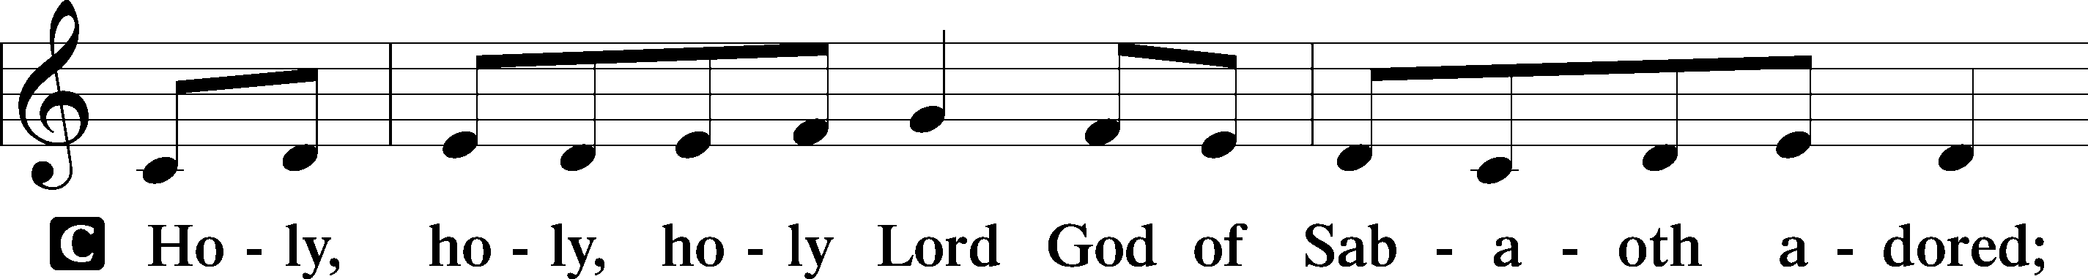
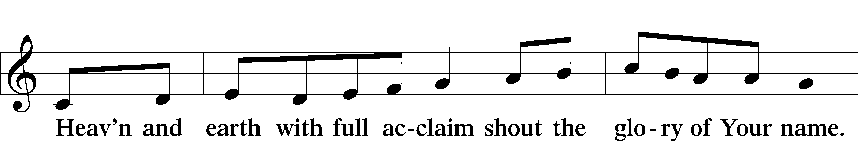

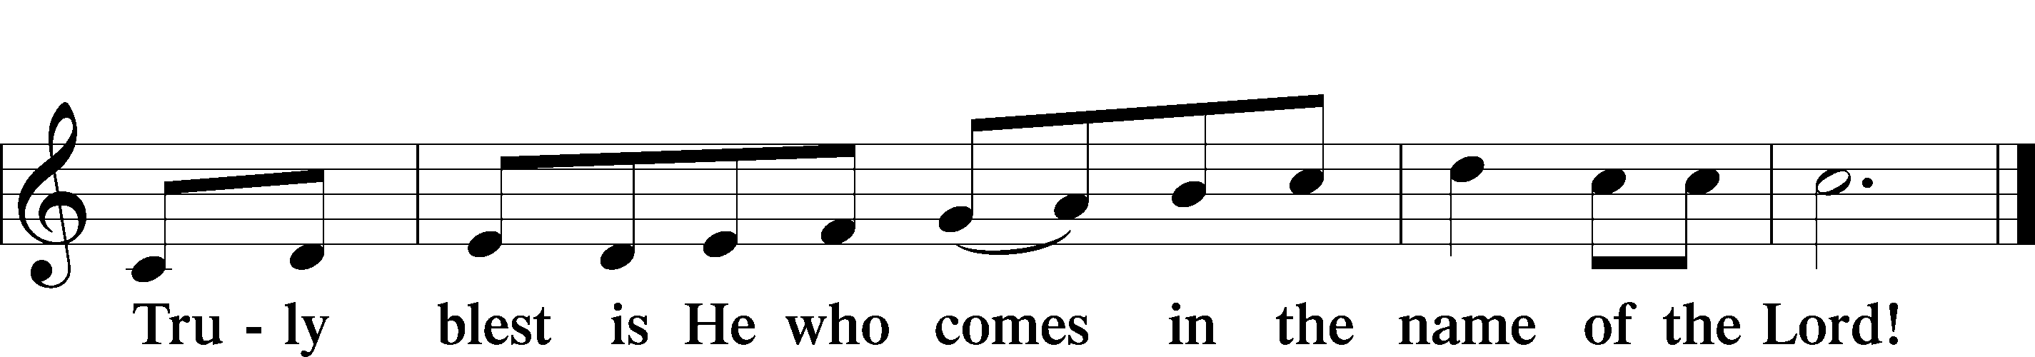

PRAYER OF THANKSGIVING
P Blessed are You, O Lord our God, king of all creation, for You have had mercy on us and given Your only-begotten Son that whoever believes in Him should not perish but have eternal life.
At Your command, Abraham prepared to offer his son Isaac as a sacrifice on the mountain; yet, in mercy You provided a ram as a substitute. We give You thanks that on Calvary You spared not Your only Son but sent Him to offer His life as a ransom for many.
As we eat and drink His body and blood, grant us, like Abraham our father, to trust in Your promise now fulfilled in Christ, the Lamb of God, who takes away the sin of the world.

THE WORDS of our LORD
P Our Lord Jesus Christ, on the night when He was betrayed, took bread, and when He had given thanks, He broke it and gave it to the disciples and said: “Take, eat; this is My T body, which is given for you. This do in remembrance of Me.”
In the same way also He took the cup after supper, and when He had given thanks, He gave it to them, saying: “Drink of it, all of you; this cup is the new testament in My T blood, which is shed for you for the forgiveness of sins. This do, as often as you drink it, in remembrance of Me.”

PAX DOMINI
P The peace of the Lord be with you always.
C Amen.

AGNUS DEI LSB 210
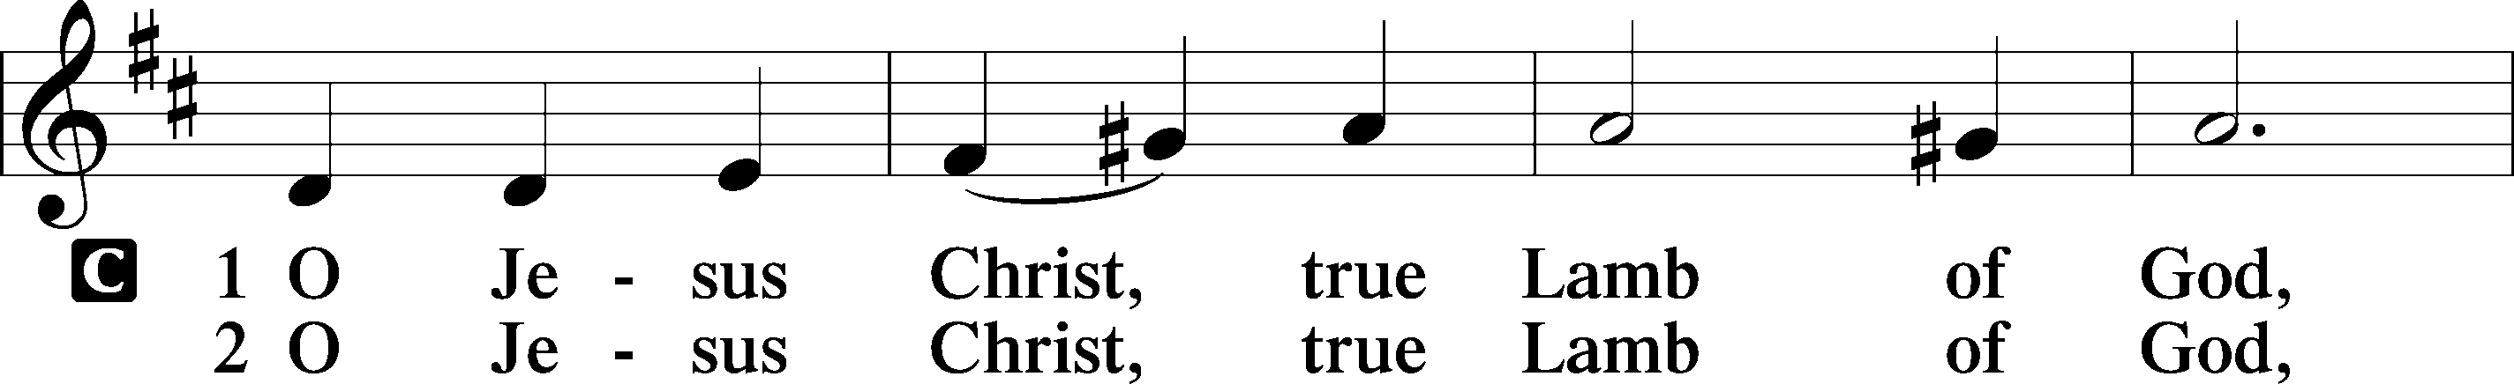
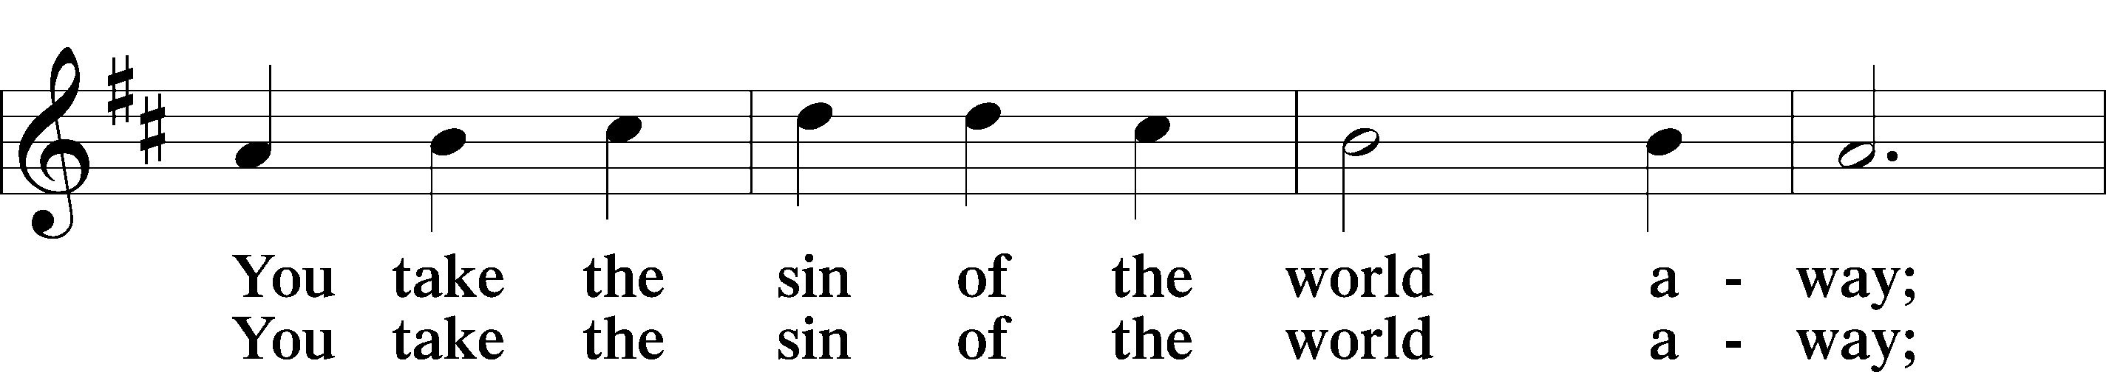
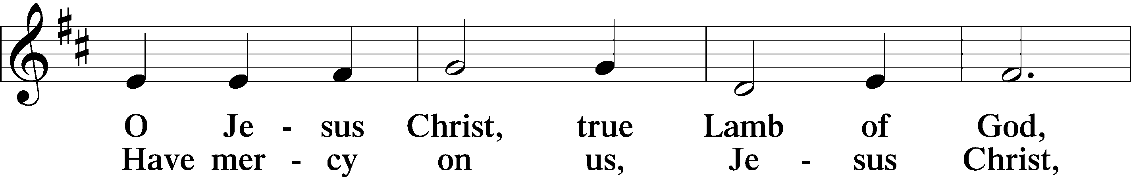
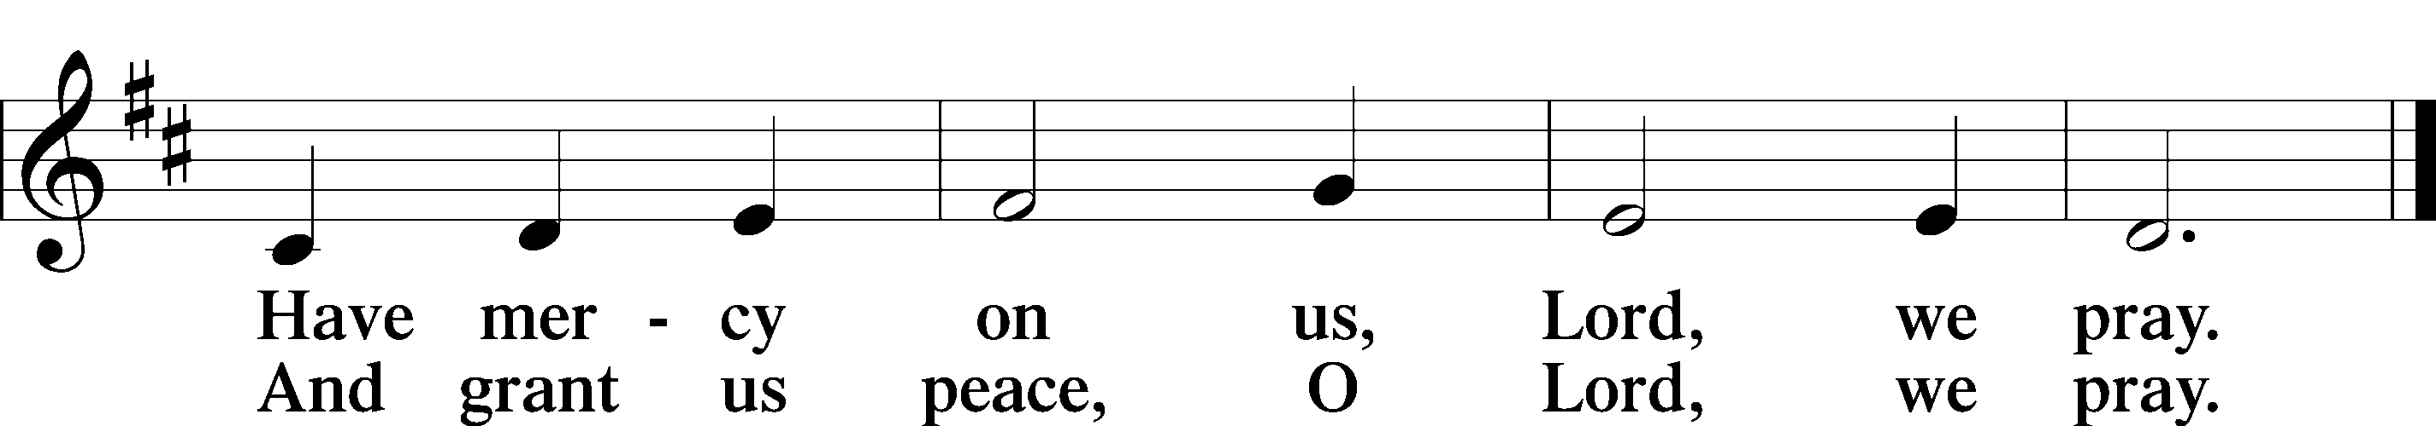

Please be Seated

The pastor and those who assist him receive the body and blood of Christ first, then Communion will be served at the rail. Ushers will help direct you forward via the center aisle; please return to your seats via the side aisles. Gluten-free bread is available for those who need it, as is non-alcoholic grape juice. Simply request either when you come forward to receive Communion.

DISTRIBUTION HYMN

Chief of Sinners Though I Be LSB 611
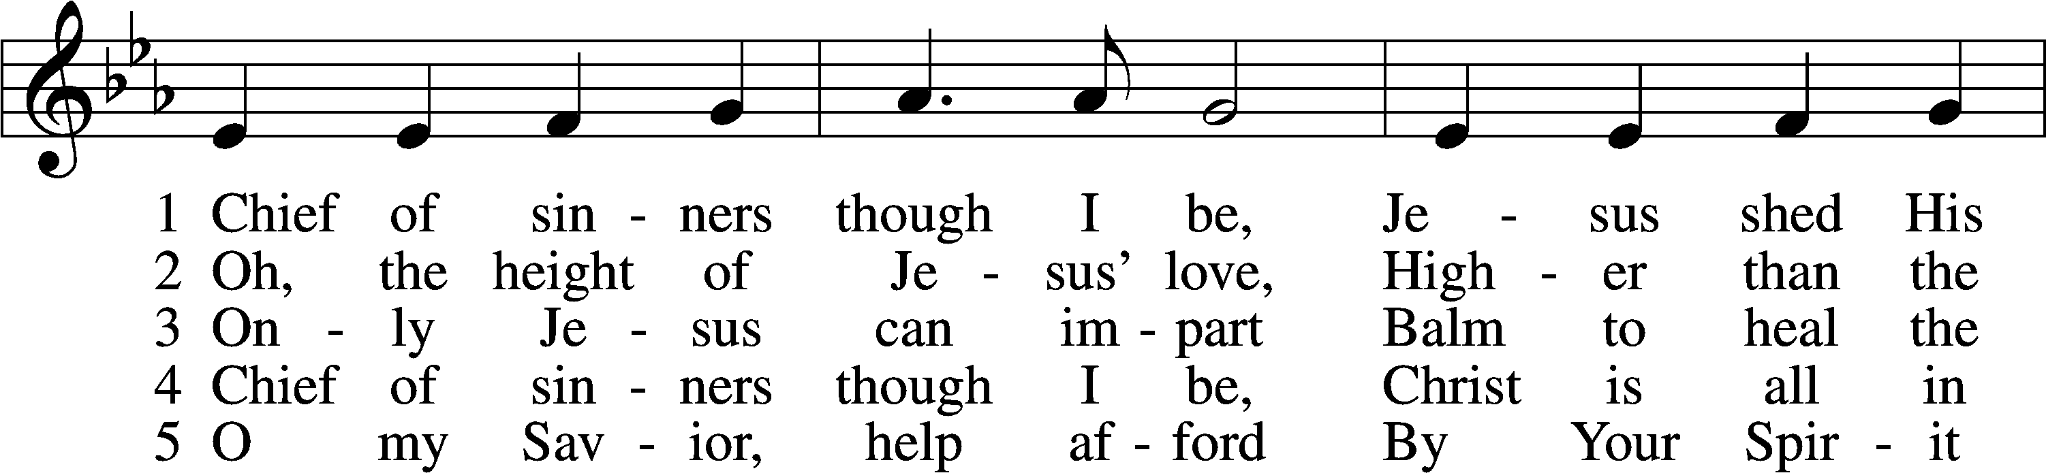
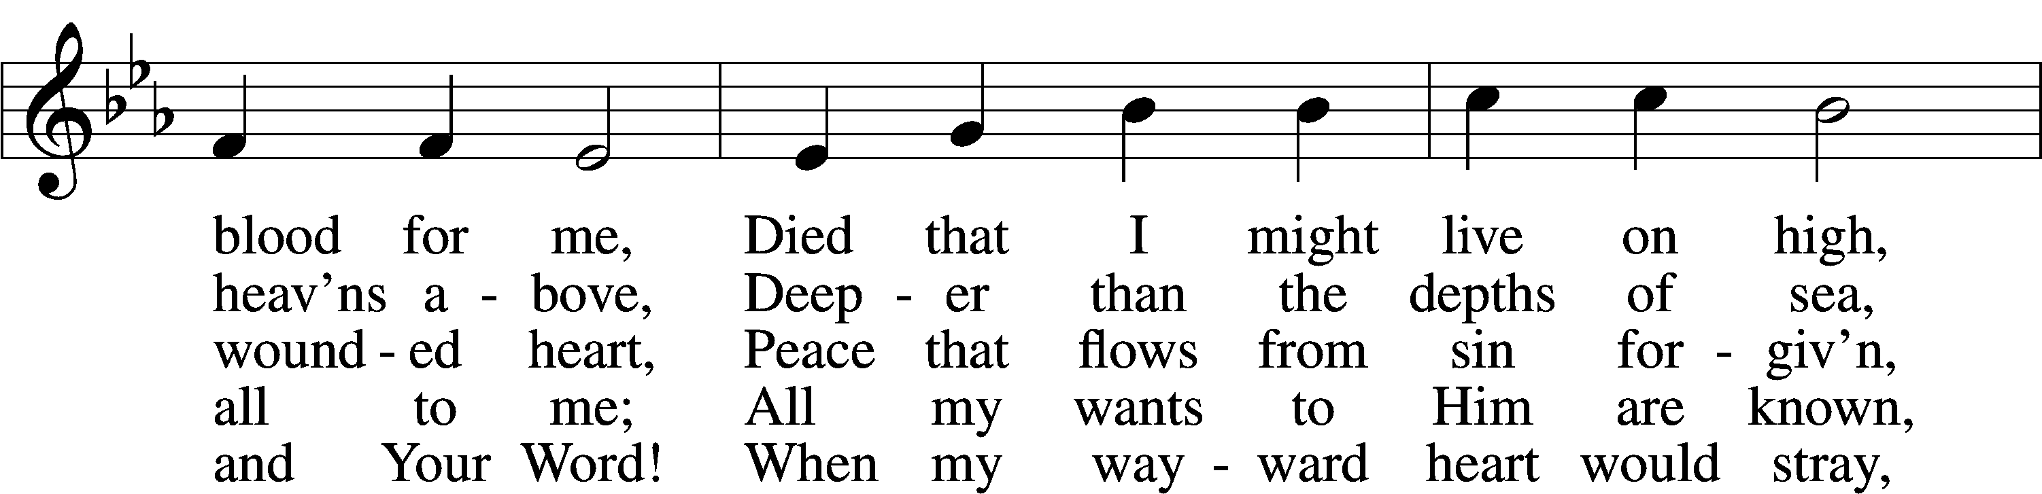
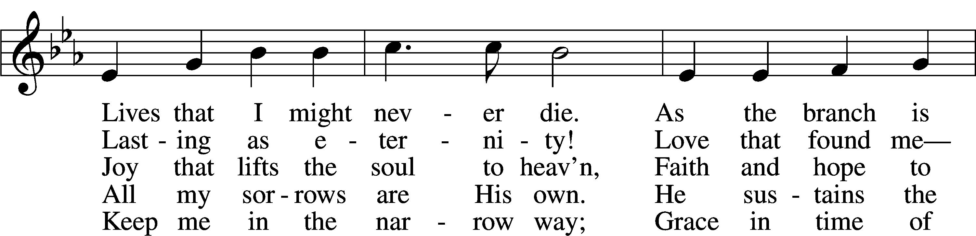
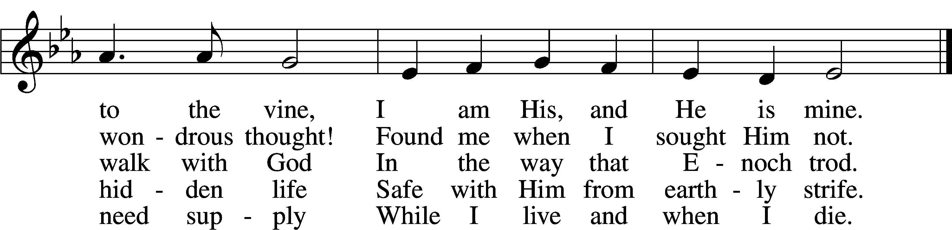

DISTRIBUION HYMN

Jesus Comes Today with Healing LSB 620 sts. 1–2
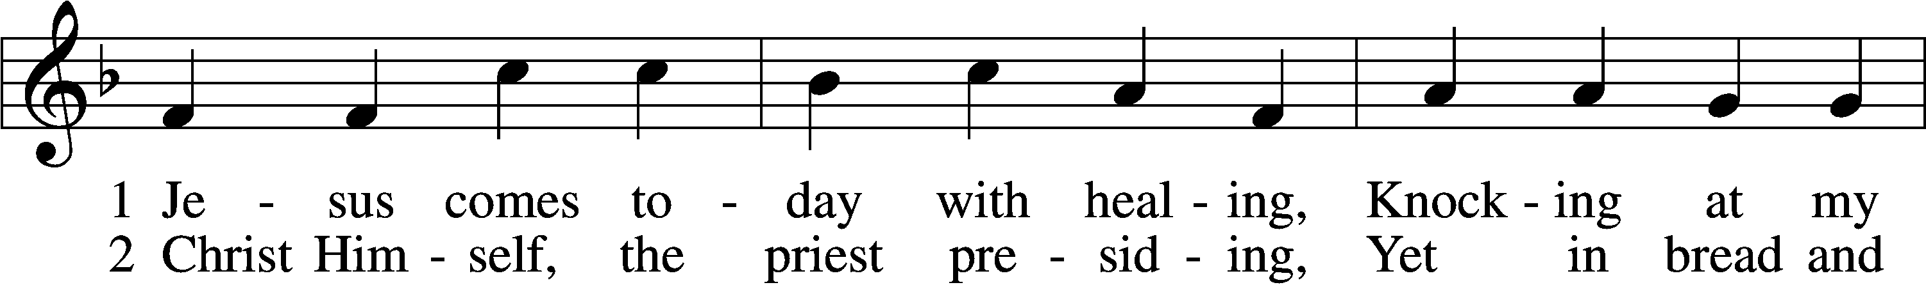
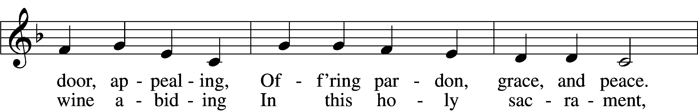
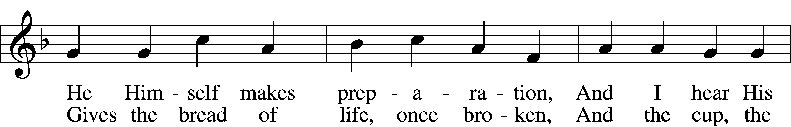
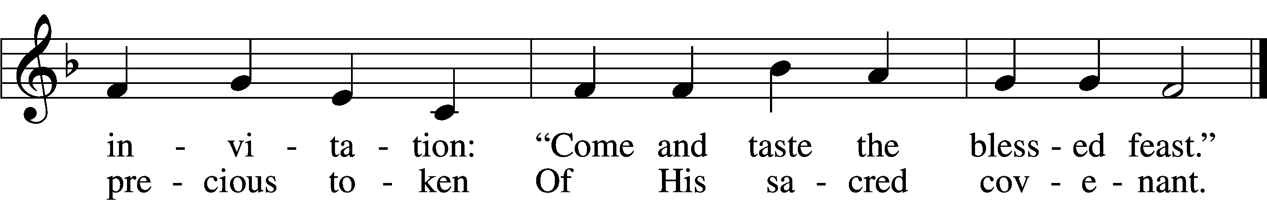

Please stand as able

NUNC DIMITTIS LSB 211
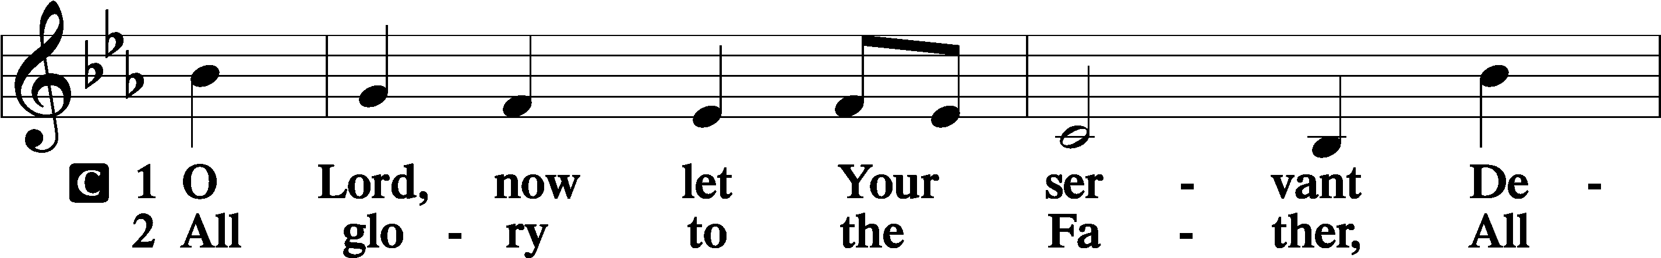
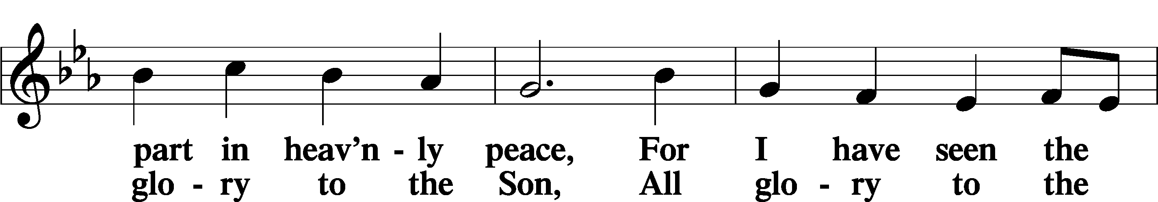
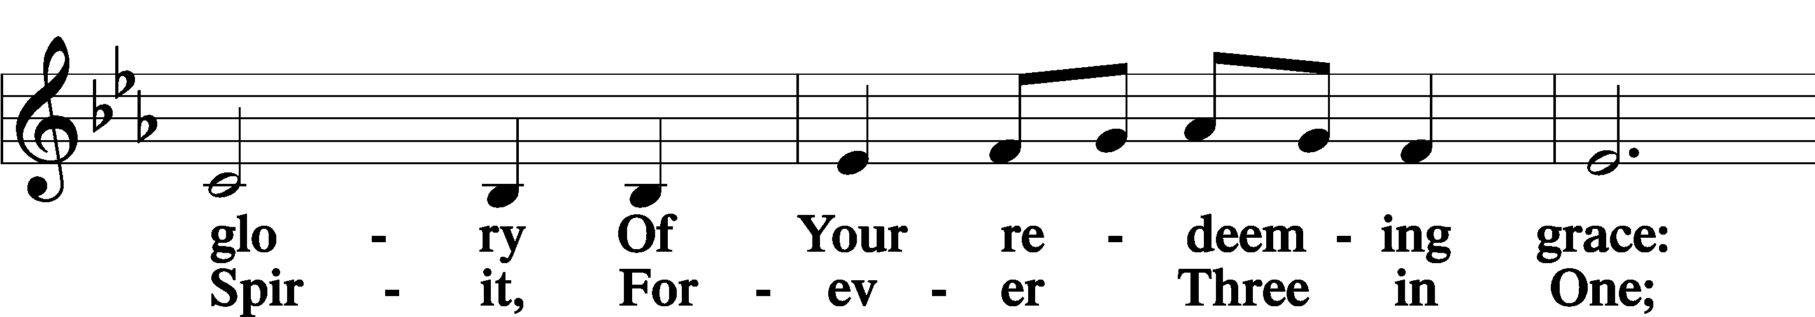
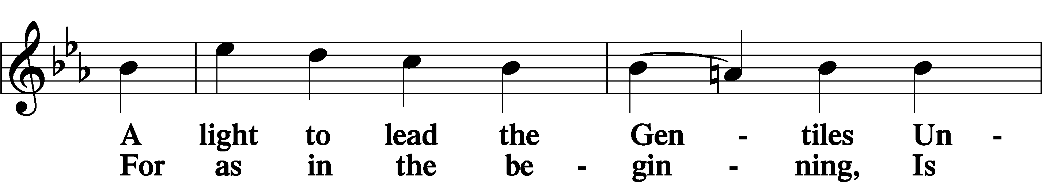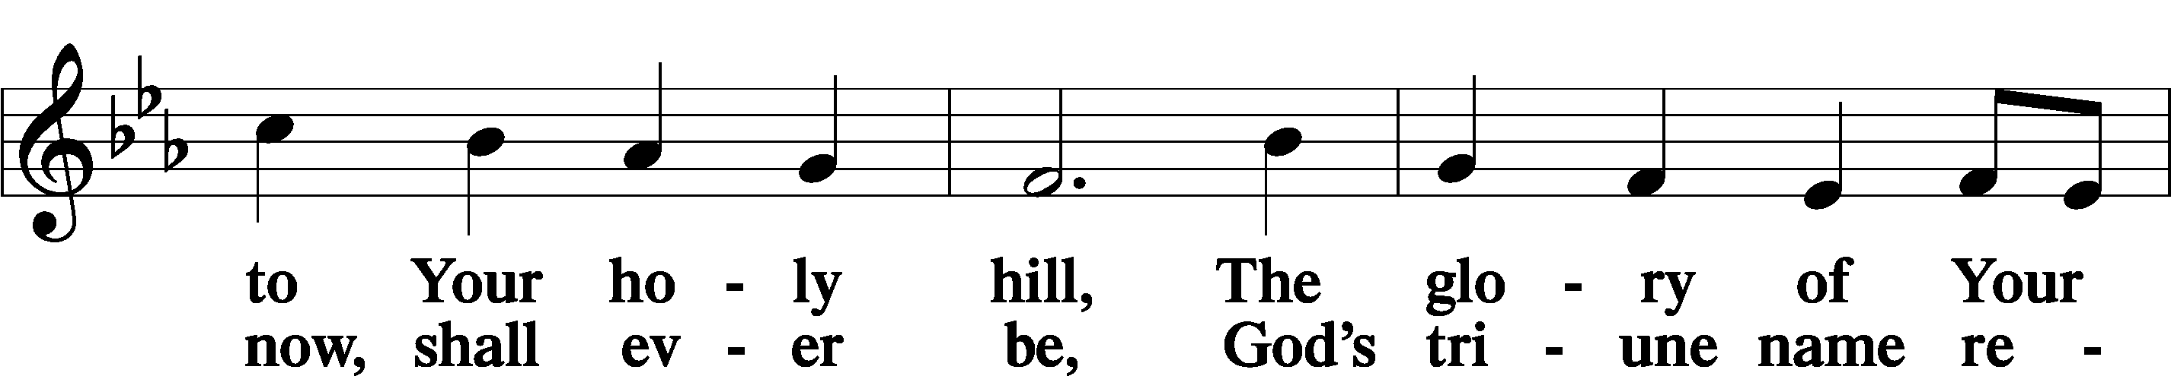
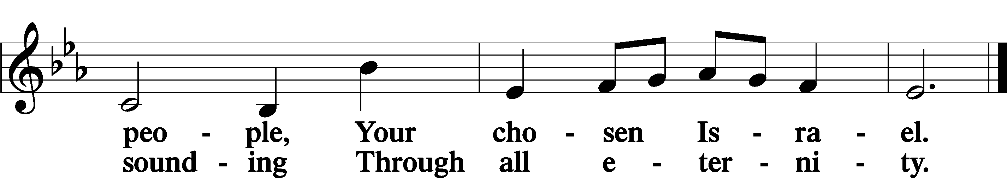

POST COMMUNION COLLECT
P Let us pray.
We give thanks to You, almighty God, that You have refreshed us through this salutary gift, and we implore You that of Your mercy You would strengthen us through the same in faith toward You and in fervent love toward one another; through Jesus Christ, Your Son, our Lord, who lives and reigns with You and the Holy Spirit, one God, now and forever.
C Amen

BENEDICAMUS LSB 212
P Let us bless the Lord.
C Thanks be to God.

BENEDICTION
P The Lord bless you and keep you.
The Lord make His face shine on you and be gracious to you.
The Lord look upon you with favor and T give you peace.
C Amen.

Please be seated

CLOSING HYMN
Christ, the Life of All the Living LSB 420 sts. 5–7
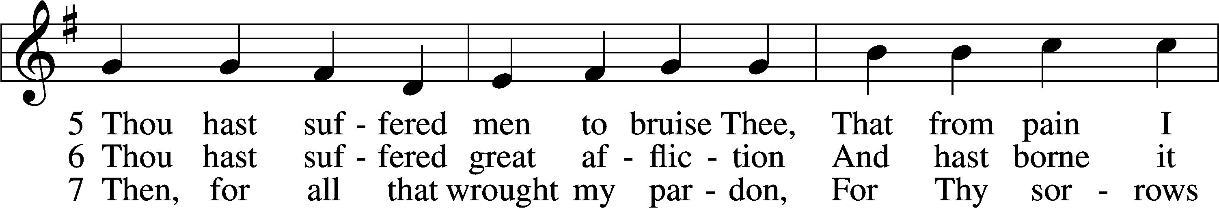
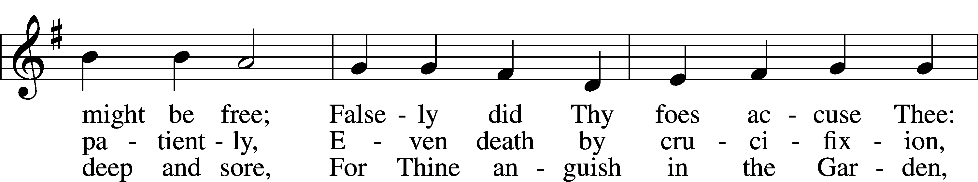
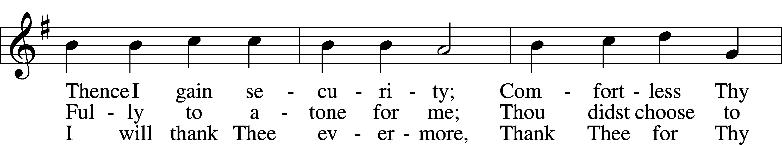
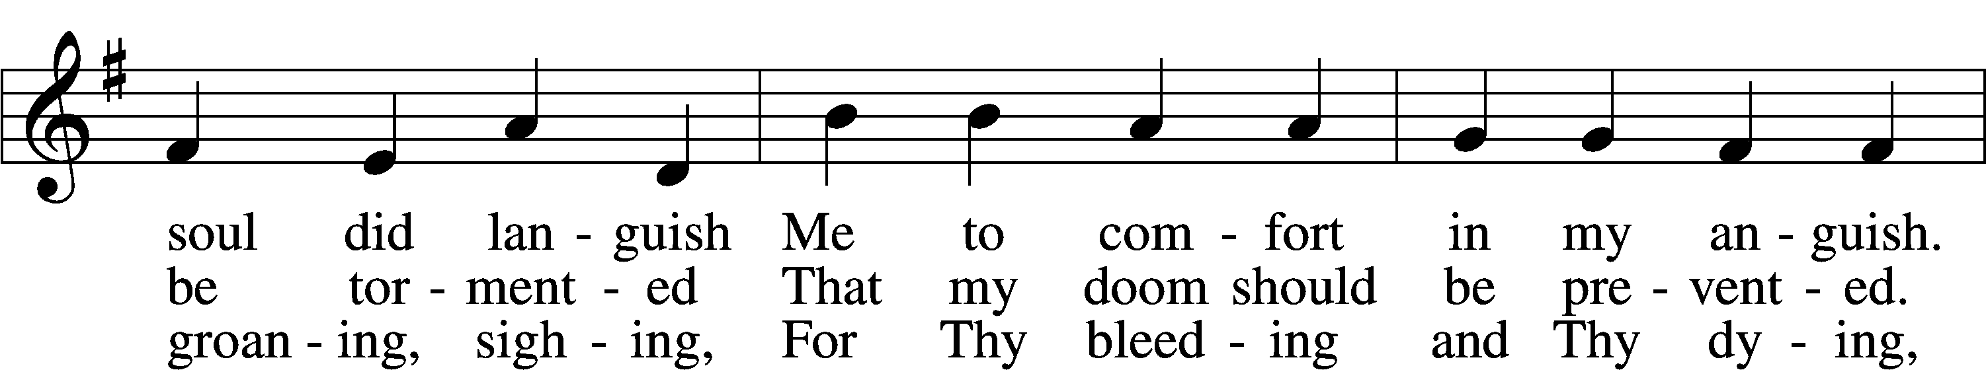
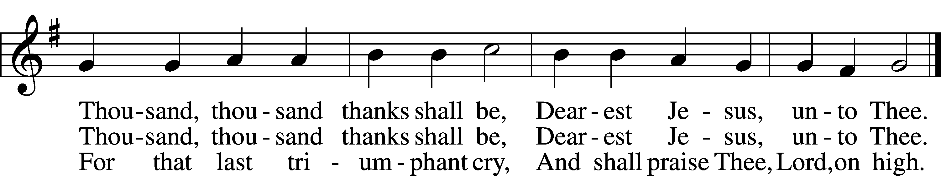

ANNOUNCEMENTS and SENDING WORDS
P We go to live for Jesus!
C We go to share His love!

Acknowledgments
Unless otherwise indicated, Scripture quotations are from the ESV® Bible (The Holy Bible, English Standard Version®), copyright 2001 by Crossway, a publishing ministry of Good News Publishers. Used by permission. All rights reserved. Created by Lutheran Service Builder. Music reproduced in this service is used with permission through: CCLI License No.1776588 and CPH – LSB Service Builder.

SERVING in GODS HOUSE TODAY
Pastor: Rev. Ken Bernthal
Elder: Tim Arner
Ushers: Bill & Terry Stiles
Greeters: Denise Lange, Tina Stier
Coffee: LWML/Kathy Erat
Counters: Brian Techel, Karl Scheiterlein
Altar Care: Pam Beasinger
Organ/Piano: Beaches
Children’s Talk: Nancy Ely
Children’s Sunday School: Nancy Ely, Jean Beach, Sharon Techel
Confirmation Class: Pastor Paul Schneider in Library

PRAYERS

Please contact the office with updates to the prayer list. People will remain on the prayer list for 4 weeks before being removed. If they need to remain on the list, please keep Elaine informed and of any updates. This will help us to have a more accurate list. Thanks for your cooperation.
Those who continue to grieve the passing of loved ones: Family of Jackie Bliss,
Family of Mariah Trybus, The Culp family.
Those with upcoming surgery and medical procedures:
Those recovering from surgery and medical procedures: Tanner Beyers, Marge Kunisch, Jean Seibel, Sandy Smith, Bill Stiles, and Tom Stier.
Those with health concerns: Tiffany Amsdill, Ruth Bennett, Hope Buchinger,
Betsy Cook, Shirley Hildebrand, Paul Kietzman, Jennifer Martin, Gladys Pickering, Eleanor Raether, Beth Smith, Judi Stutzman, Joann Whitney, and Lyle Yingling.
Those diagnosed with cancer: Sue Cavanagh, Leah Eicher, Rachel Frisch, Leslie Martin, Brian Morgan, Hope Osantowski. Leanne, Sheryl Marsh, and Larry Schiewe.
Those under Hospice Home Care: Ken Williamson, Jim (Joann Whitney brother-in law)
MESSAGES

MEMBER & GUEST CARDS: If you have not filled out a member/guest card, please take the time to fill one out and place it in the plate behind the back pews in our sanctuary.
WEDNESDAY MORNING BIBLE STUDY, 10:00am in the fellowship hall with Pastor Ken Bernthal.
GREETING CARDS If you are in need of some greeting cards, we carry an array of them in the cabinet in the library. Easter cards have been put out. The cost of the cards is posted on the cabinet. The money collected from the cards goes to LWML to help support Missions.
CANCER and FRIENDS SUPPORT GROUP: Will be meeting March 28th
Please remember Cancer & Friends Support Group is not just for people going through treatment, or survivors, we are also here for caregiver, spouse, children, and friends anyone touched by cancer. There are times when we can all use someone to talk to especially when trying to over the hills and mountains, during those difficult times. We do not give medical advice, the advice we give is through our own experience. If there is any subject you would like to discuss at the meeting or privately please feel free to call or text me at 989-350-4391. Hope you will join us.
KUT-UPS will be meeting Monday March 20th, 10am in the fellowship hall.
USE OF FELLOWSHIP HALL; Do you need a place to hold a function? Baby Shower, Wedding Shower, Birthday Party? The church fellowship hall is open for members and non-members to use. Fill out the Use Form in the church office and we can help you secure the church for your event. This has to be cleared through the proper channels for the use of the church. So please fill out a month in advance for earlier if possible. There is a TV in the fellowship hall that will allow you to access different applications you can show a slide show using training video and much more. If you have any questions feel free to call the church or send me an email to tina.vantil@gmail.com
HOME BIBLE STUDY GROUP:: We are working on developing a new Home Bible Study Group. If you have interest in participating in such a group, please let the office know, or contact Kathy Erat, 989-732-7153.

NLPRC BABY BOTTLE CAMPAIGN: We thank all who have turned in the baby bottles filled with donations for New Life Pregnancy Resource Center. If you still have a bottle to return, please bring it in to church as soon as possible. Our time for collections was the month of February, but they still welcome late donations. Every donation is appreciated!

BIRTHDAYS: ANNIVERSARIES:
3/14 Paul Schneider 3/12 Richard & Susan Straith
3/15 Leslie Martin 3/14 Denise & Brian Rood
3/16 Liam Albrecht 3/17 Greg & Sharon Techel

READINGS FOR NEXT WEEK
First Reading: Isaiah: 42:14-21
Second Reading: Ephesians: 5:8-14
Holy Gospel: Mark: 15:37-39:

SERVING in GODS HOUSE NEXT WEEK

Pastor: Rev. Ken Bernthal
Elder: Ron Tesolin
Ushers: Larry & Joann Whitney
Coffee:
Counters: Kayla Albrecht, Leslie Martin
Altar Care: Judi Stutzman
Children’s Talk: Nancy Ely
Virtual Organist: Bob Erat
Children’s Sunday School: Nancy Ely, Jean Beach, Sharon Techel
Confirmation Class: Pastor Paul Schneider in the Library

THIS WEEK AT TRINITY

March 19 Sunday
9:00 am Worship Service – Holy Communion
10:00 am Fellowship & Coffee Hour
10:30 am Children’s Sunday School.
10:30 am Confirmation Class Pastor Paul Schneider (in Library)

March 20 Monday
NEWSLETTER DEADLINE

March 21 Tuesday
6:30 pm Church Council Meeting – Fellowship Hall

March 22 Wednesday
10:00 am Wednesday Morning Bible Study W/ Pastor Ken Bernthal

March 23 Thursday

March 24 Friday
St. Patrick’s Day
11:00 am LWML Zone Board Meeting (Fellowship Hall)

March 25 Saturday

March 26 Sunday
9:00 am Worship Service - Holy Communion
10:30 am Fellowship & Coffee Hour
10:30 am Children’s Sunday School.
10:30 am Confirmation Class Pastor Paul Schneider (in Library)

